## Problem 1. Sweet Dessert

Ivancho and his girlfriend are **throwing a party**. She plans **to cook her favorite dessert**. She asks Ivancho to **buy** the **needed products**. The **number of desserts** depends on **how many people will be coming**. She can prepare the dessert **in portions of 6**. If there are **5 guests** coming, she will still **cook 6 portions**, for **10 guests** – will **cook 12**. The products for the dessert are **bananas**, **eggs** and **berries**. For **a set of 6** she needs **2 bananas**, **4 eggs** and **0.2 kilos berries**.

You will be given **the amount of money Ivancho has**, the **number of guests** and the **prices of the products**. You have to help Ivancho **calculate** if the **cash** he has is **enough to buy all of the products**, or how much more money he needs.

### Input

The input data should be read from the console. It will consist of **exactly 5 lines**:

* The **amount of cash** Ivancho has – **floating-point number** in **range [0.00…1,000,000,000.00]**
* The **number of guests – integer in range [0…1,000,000,000]**
* The **price of bananas** for a **single unit – floating-point number** in **range [0.00…1,000.00]**
* The **price of eggs** for a **single unit – floating-point number** in **range [0.00…1,000.00]**
* The **price of berries** for a **kilo – floating-point number** in **range [0.00…1,000.00]**

The **input data will always be valid** and in the format described. **There is no need to check it explicitly**.

### Output

The output should be printed on the console.

* **If the calculated price of the products is less or equal to the money Ivancho has:**
  + “Ivancho has enough money - it would cost {the cost of the products}lv.”
* **If the calculated price of the products is more than the money Ivancho has:**
  + “Ivancho will have to withdraw money - he will need {neededMoney}lv more.”
* **All prices** must be **rounded to two digits after the decimal point.**

### Examples

|  |  |  |
| --- | --- | --- |
| **Input** | **Output** | **Comments** |
| 10  12  0.35  0.20  4.50 | Ivancho has enough money - it would cost 4.80lv. | For 12 guests – 2 sets of 6 portions  Needed product:  2*(2 bananas), 2*(4 eggs), 2*(0.2 kilos berries)  2*(2*0.35) + 2*(4*0.20) + 2*(0.2*4.50) = 4.80  4.80 <= 10 – the money will be enough. |
| **Input** | **Output** | **Comments** |
| 20  33  0.60  0.50  10 | Ivancho will have to withdraw money - he will need 11.20lv more. | For 33 guests – 6 sets of 6 portions  Needed product:  6*(2 bananas), 6*(4 eggs), 6*(0.2 kilos berries)  6*(2*0.60) + 6*(4*0.50) + 6*(0.2*10.00) = 31.20  31.20 > 20 – need 11.20 lv. more. |

# Solution

## Read the Input

First, we need to read from the console 5 lines of input and parse them to the appropriate data type.

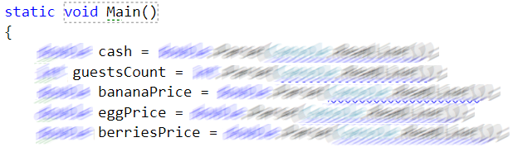

## Calculate the Number of Portions

To calculate the number of portions we need to divide the number of guests to 6 and round up to the nearest integer.

cc2

## Calculate the Needed Money

To calculate needed money for the desserts with the formula

Needed money for 1 product = number of portions * quantity needed * price of the product

We calculate that for all the 3 products and add their values.

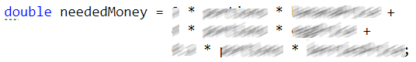

## Make a Decision

If the needed money is less or equal to the money Ivancho has we print that Ivancho has enough money otherwise we print the amount of money Ivancho need to buy products for the desert. Rounded 2 digits after the floating point.

